FORECASTING TOURIST ARRIVALS IN NEW YORK CITY USING TIME-SERIES PREDICTIVE ANALYTICS

TABLE OF CONTENTS
1. Introduction 3
2. Problem Definition 3
3. Aim and Objectives 3
4. Scope 4
5. Methodology 4
5.1 Data Preparation 4
5.2 Exploratory Data Analysis 5
5.3 Predictive Modelling 5
5.4 Model Evaluation 5
5.5 Technologies and Tools 5
6. Data Sources 6
7. Expected Deliverables 6
8. Project Timeline 7
9. Ethical and Legal Considerations 7
References 9

1. Introduction
Tourism is an important business sector in New York City, where changes in visitor demand influence accommodation, transport, staffing, and other tourism services. Seasonal fluctuations and patterns in tourist behaviour can cause tourist arrivals to vary from period to period. The changes can pose difficulties for tourism businesses in making capacity decisions and an effective allocation of resources. If not correctly identified, future needs could mean scaling up service provision, potentially leading to inefficient use of service resources, or increasing competition for services if too few are provided. Consequently, the historical trends of tourist arrivals can be analysed and important demand trends established, and this will help to make more informed planning choices. This project aims to explore historical tourist visit events in New York City, analyze trends and seasonal patterns, and create a model to predict tourist visits in the city. Forecasts will be generated that will offer evidence to support tourism planning and enhance resource allocation decision-making related to tourism services and operations.

2. Problem Definition
Tourism organisations in New York City experience fluctuations in tourist demand across different periods, making it difficult to plan accommodation capacity, staffing, transport, and other tourism resources effectively. Rising demand during certain periods of the year, such as the summer holiday season, can draw on scarce resources, and periods of lower demand can lead to underutilised resources. Such uncertainty can have implications for how long tourist flows are planned and how the tourism resources are used. This lack of certainty can have an impact on operational planning and efficient use of the tourism resources. Historical tourist arrival figures can supply evidence as to how demand shifts over the years and can be analysed to find the regularities and retrieve the seasonality (Rizal, 2025). The project will explore these patterns through the historical data and create a forecasting method with time series analysis that can predict the number of tourists that will travel to New York City in the future. The Project therefore sets a link between the business problem, the available data, Data Science analysis, predictive forecasting, and business decision-making, as recommended by the CCT guidance for a strong capstone project, providing a better evidence base for future tourism operations planning.

3. Aim and Objectives
Aim: The primary aim is to analyse historical tourist arrival patterns in New York City and develop a time-series forecasting model to support tourism planning and resource allocation.
Objectives
- To collect, clean, and prepare historical tourist arrival data for New York City for analysis.
- To analyse historical tourist arrival data using exploratory data analysis to identify trends, seasonal patterns and significant variations.
- To develop an appropriate time-series forecasting model for predicting future tourist arrivals in New York City.
- To evaluate the forecasting model using appropriate performance measures and compare its performance against a baseline approach.
- To interpret the forecasting results and develop practical recommendations to support tourism planning and resource allocation in New York City.

4. Scope
The project will emphasize historical tourism arrival data to be analysed to find trends, seasonality, and patterns that can inform a forecast of future demand for New York City. Data collection, data cleansing, exploratory data analysis, data visualization, time-series trend and seasonal analysis, development of a relevant time-series forecasting model, model evaluation, and interpretation of results will be considered. Python-based tools will be used to implement the analytical and predictive workflow. The project will also translate the forecasting results into practical suggestions on what to do when planning tourism and allocating resources (Kim et al., 2025). The project will not include real-time tourist prediction, the tracking of individual tourists, and the real-time collection and processing of personal or sensitive data. Also, booking and payment systems will not be included, and neither will be the complete tourism management.

5. Methodology

5.1 Data Preparation
The first step of the project will be the collection of historical data about tourist arrivals in New York City and its preparation in Python. The Pandas library will be employed to examine the data, identify missing values, data duplications, data types, and to process input variables of the type ‘date’. Outliers will also be explored where appropriate to see if the outliers will have an impact on the forecasting results (Wu et al., 2026). The collected data will be structured in an appropriate time series representation that standardises and validates it for further analysis and modelling.

5.2 Exploratory Data Analysis
The data analysis will be performed using exploratory Data Analysis (EDA) tools like Pandas, Matplotlib and Seaborn. Tourist numbers through time will be analysed to look for overall trends, seasonal trends, and variations in demand. The patterns on a monthly and annual basis will be visually presented to ensure that the high and low tourist periods can be highlighted (Gao et al., 2025). An examination will also be conducted for growth and changes in visitors' demand. These results will help to provide an evidence-based knowledge of the tourism pattern and will inform the approach for forecasting.

5.3 Predictive Modelling
A baseline forecasting method is first developed, such as Naïve Forecast or Moving Average, to allow a reference point to be established for assessing predictive performance. Once a desired time-series forecasting model (such as ARIMA) is selected, it will be used to predict the future number of tourists at an appropriate time (Singgalen, 2025). But it will be a specific model and not just a complicated technique that will be chosen depending on properties of the available data and the specific forecasting demands. This aligns with the CCT guidance to use Data Science techniques based on the business problem they aim to address.

5.4 Model Evaluation
The forecasting model will be evaluated using appropriate performance measures, including Mean Absolute Error (MAE), Root Mean Square Error (RMSE) and, where suitable, Mean Absolute Percentage Error (MAPE). Performance of the forecast will be evaluated against the “baseline” method to check if the chosen model can better and more usefully predict future tourist numbers.

5.5 Technologies and Tools
This project will be written in Python and will utilize various libraries such as Pandas, NumPy, Matplotlib, Seaborn, and Scikit-learn. The development environment will be Google Colab or Jupyter Notebook. These technologies will be utilized for data preparation, data visualisation, exploratory analysis, forecasting, model checking, and understanding (Gibson and Connell, 2025).
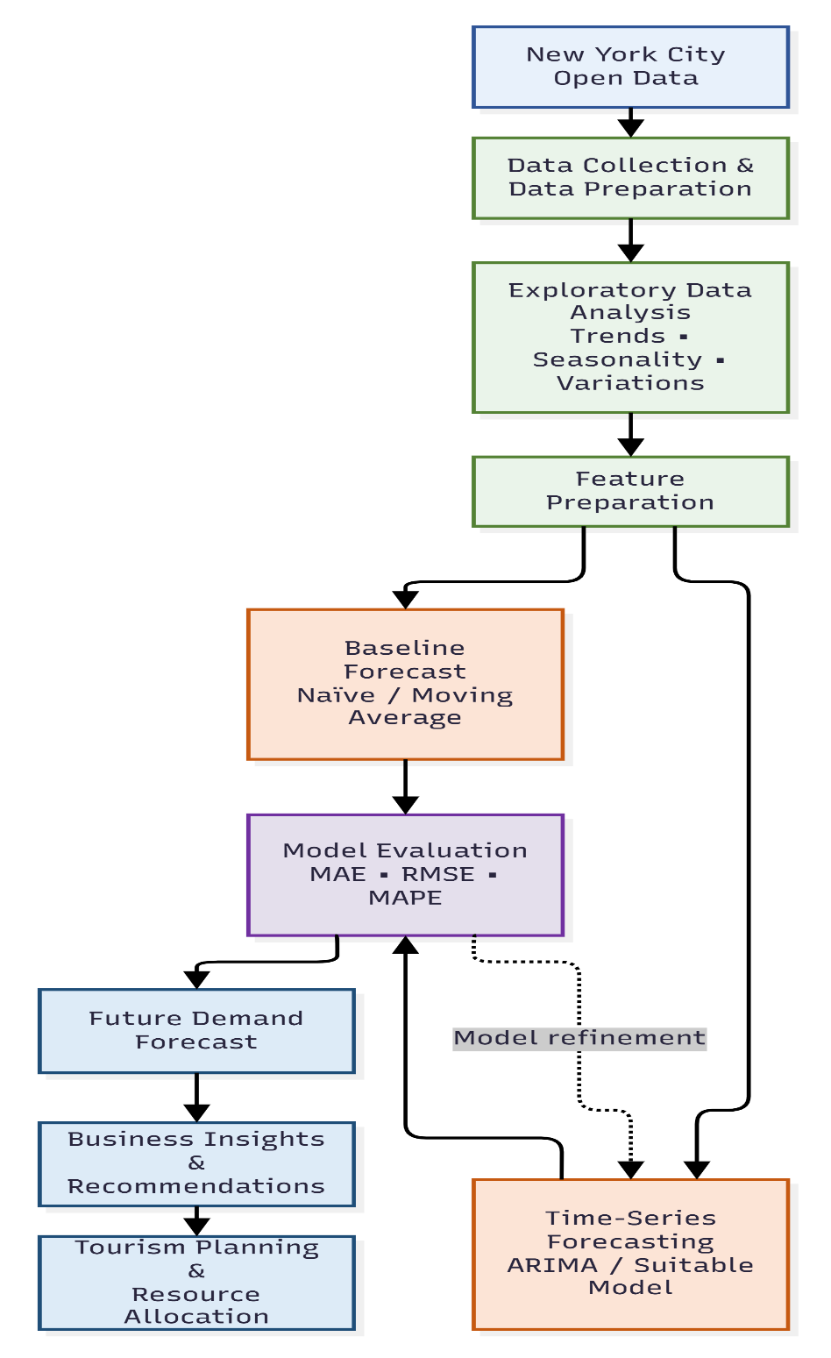

Figure 1: Proposed Tourism Demand Forecasting and Business Decision Workflow
(Source: self-created in draw.io)

6. Data Sources
The project will use the New York City Airbnb Open Data dataset available through Kaggle. The data refers to Airbnb listings in NYC over time, stored in CSV format, and can be analyzed using Python and Pandas. Factors that may be relevant are the neighbourhood, type of room, the price, the minimum number of nights that have been requested, the number of reviews received, as well as the number of reviews/useful month, and availability. The data set will be analyzed to detect missing cases, duplications, data types, and consistency of data. Its geographical coverage is only available for NYC, which is the selected location (Li and Li, 2025). The pattern of accommodation availability and the demand for tourism will be studied on the basis of the data set. Kaggle will be referred to as the source for data, and the conditions of using the data as mentioned in the data licence will be checked before implementation. There is low risk of privacy issues as the data set does not contain the primary information of tourists that can be directly identified. It will be evaluated based on the Comprehensiveness, relevance, and analytical value when used in the proposed project.

7. Expected Deliverables

Semester 1
The first semester will lay the analytical base for the project. The final product will be a cleaned and prepared set of data for the New York City Airbnb dataset, along with exploratory data analysis and visualisations that display patterns in how people are staying in NYC and the demand for tourism opportunities. The first results will pinpoint key characteristics of the data and inform the choice of a forecasting technique. Additionally, a baseline forecasting model will be created as a benchmark for future models.
Semester 2
The second semester will be dedicated to finalizing and testing the predictive solution. The final forecasting model and model evaluation results/future demand prediction will be the deliverables. Data preparation, analysis, modelling and evaluation will be documented in a full Python notebook and using supporting code (Gkarane et al., 2025). Key findings and forecasting results will be communicated through visualisations. The project will deliver information which can be used to inform tourism planning and resource allocation.

8. Project Timeline
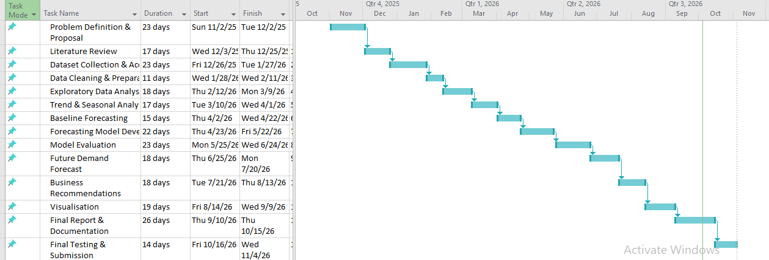
Figure 2: Gantt chart
(Source: self-created in MS project)

9. Ethical and Legal Considerations
The project will leverage the New York City Airbnb Open Data dataset provided by Kaggle and subject to the terms and licence on the dataset website. The dataset will be used with the condition of data ownership, as well as a data licence check and appropriate acknowledgement of the original data provider. There will be no need for redundant collection of personal or potentially identifiable information within the project, and no effort will be made to identify individual users or hosts (Pham et al., 2025). Where relevant, the following GDPR and data-protection principles will be taken into account: Responsible use, privacy, and data minimisation. Dataset files will be stored securely with access restrictions where appropriate, and project outputs will be securely stored. Analytical and forecasting results will be expressed clearly and honestly, appreciating the fact that forecasting models are not flawless and have uncertainty.

References
Journals
Rizal, A.A., 2025. Comparative Evaluation of Forecasting Methods for Tourist Arrival Prediction: A Sliding Window-Based Analysis. CogITo Smart Journal, 11(1), pp.152-166.
Kim, J., Kim, H., Kim, H., Lee, D. and Yoon, S., 2025. A comprehensive survey of deep learning for time series forecasting: architectural diversity and open challenges. Artificial Intelligence Review, 58(7), p.216.
Wu, X., Qiu, X., Cheng, H., Li, Z., Hu, J., Guo, C. and Yang, B., 2026. Enhancing time series forecasting through selective representation spaces: A patch perspective. Advances in Neural Information Processing Systems, 38, pp.23328-23354.
Gao, H., Li, H. and Zhang, C.J., 2025. Time and feature varying tourism demand forecasting. Annals of Tourism Research, 112, p.103959.
Singgalen, Y.A., 2025. Big data in tourism and hospitality industry: predictive analytics of hotel room trends. Indonesian Journal of Tourism and Leisure, 6(1), pp.1-17.
Gibson, C. and Connell, J., 2025. Popular culture and tourism: Conceptual advances and future directions. Tourism Geographies, 27(3-4), pp.767-778.
Li, Z. and Li, Z., 2025. Research on the optimization model of digital resource allocation in cultural and tourism industry based on reinforcement learning. J. COMBIN. MATH. COMBIN. COMPUT, 127, pp.2617-2631.
Gkarane, S., Vassiliadis, C., Kotzaivazoglou, I., Fragidis, G. and Vrana, V., 2025. Combating seasonality in regional tourism: A call to action through sport events and practitioner insights. Tourism and Hospitality, 6(2), p.66.
Pham, K., Andereck, K.L. and Vogt, C.A., 2025. Stakeholders’ involvement in an evidence-based sustainable tourism plan. Journal of Sustainable Tourism, 33(4), pp.673-696.

